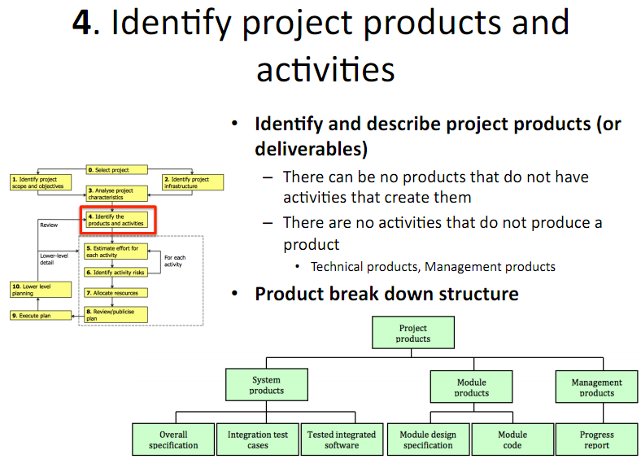

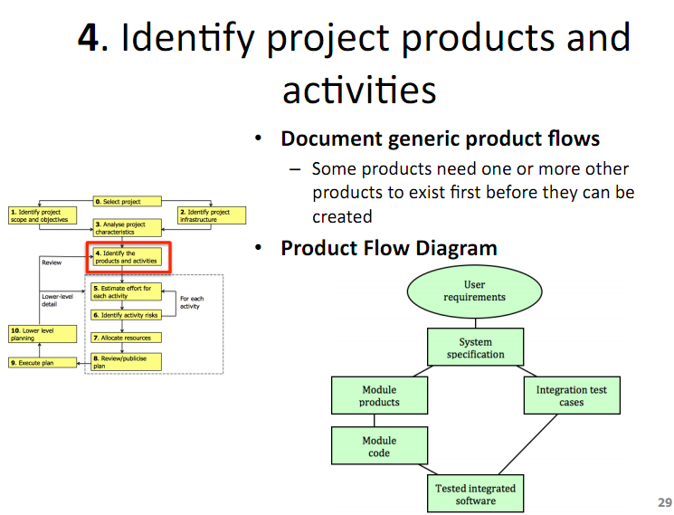

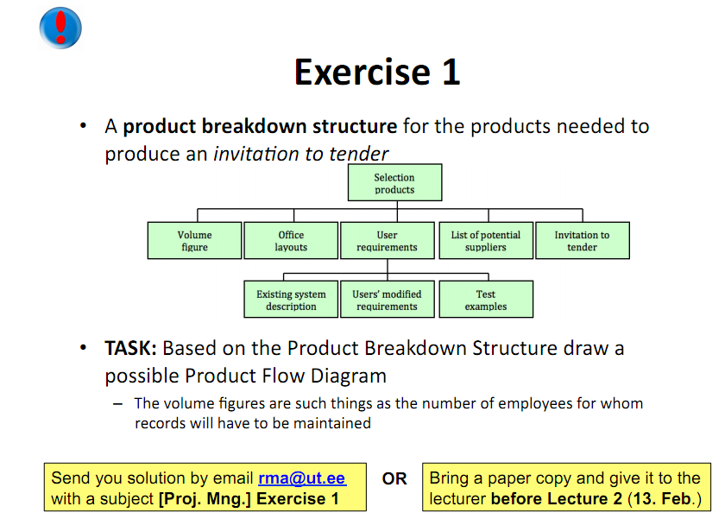

Invitation to tender = Ausschreibung

User Requirements

-> Existing System Description & Office Layout

-> Test Examples

-> User’s modified requirements & List of Suppliers

-> Invitation to tender

User Requirements & Existing System Description

-> Test Examples

-> User’s modified requirements & List of Suppliers

-> Invitation to tender